**Excel Assignment - 9**

1. What are the different margins options and do we adjust the margins of the excel worksheet?

**Ans:** Normally you have four types of margins which are top, bottom, left and right. When you open the workbook by default we have margin of 0.75 inches to the top & bottom and 0.70 inches of the left & right.

We can adjust the margins in Page Layout tab -> Page Setup -> Margins

In Margin, we have mainly three types of Margins i.e. Normal, Wide and Narrow and the exceptional one is Customs Margins.

Most of the times, we don’t use margin in Excel but while printing the sheets, you will have the option to choose the margin like I mentioned in last paragraph So most of the people use while printing.

2. Set a background for your table created.

**Ans:** Once you open the workbook, Page Layout -> Background -> Browse from your computer/select it from Bing -> click OK.

To make table Visible, fill it with other colors – CTRL+SHIFT+F

3. What is freeze panes and why do we use freeze panes? Give examples.

**Ans:** Freeze Panes are use to lock the row/column So that it will display as you go through the workbook.

This feature is to keep an eye on worksheet visible while you scroll to another area of the worksheet.

Click on row/column which you want to freeze it, go to View tab -> Window Grouping -> Freeze Panes

Example:

Here, I want to freeze my first row, So I can see first row while scrolling the sheet. Here you can see first row number 1 and then below that you can see directly 20, it seems first row is freeze.

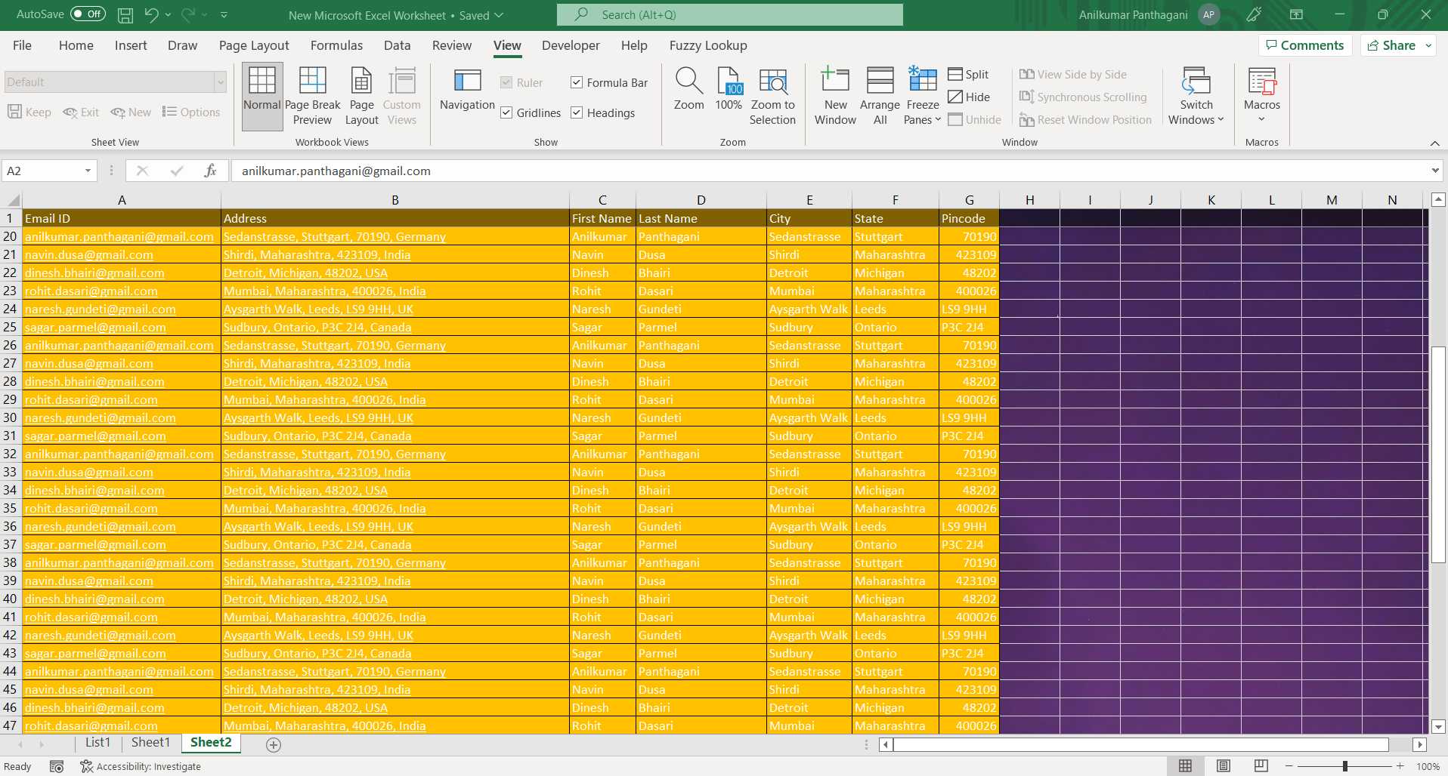

4. What are the different features available within the Freeze Panes command?

**Ans:** We have three different commands under freeze panes,

1. Freeze Panes
2. Freeze top row
3. Freeze first column

Once you use any of these option to freeze the row/column then there will be another option that is **Unfreeze Panes.**

5. Explain what the different sheet options present in excel are and what they do?

**Ans:** Once you create the workbook, by default you have 3 sheets named as Sheet1, Sheet2 and Sheet3. For more sheets you can required number of sheets by clicking **+** symbol beside sheets.

You have several option to perform from the sheet options.

1. Ribbon sheet option.

Ribbon sheet option can be access by following steps:

Page Layout -> Sheet option in grouping

It has four options, two for Gridlines – View & Print and two for Headings – View & Print.

You can select and deselect according to your need.



You can expand this ribbon sheet option by clicking like below mentioned screenshot then, in this you have few other options.

1. Right click on Sheet.

You have multiple options as you can see on below picture.

In **Insert** option, you can insert new sheet/chart sheet/macro sheet/dialogue box sheet.

If you want to **delete** specific sheet then you can **delete** that sheet by right clicking on sheet.

In the same manner, you can **rename** the sheet as well.

You have **Move or Copy** option to move or copy the sheet to new/existence sheet.

In **View Code**, you can see all the code which are entered in VBA in that specific sheet.

Once you click on **Protect Sheet,** you will see many options to choose. Enter the Password and then Select the required options then **OK.** This option will not give any permission to other people to edit.

**Tab Color** is the option in which sheet tab can get the color you choose.

**Hide -**  It is to hide the sheet.

Once you hide the sheet then **Unhide** option will be visible to choose to unhide the sheet which you kept in hide.

**Select All Sheets** – This is the option to select all the sheets and all the listed options are available to apply to all the sheets at once.